Cookbook your virtual kitchen assistant – Frontend Documentation

# 1. Project Title

Cookbook your virtual kitchen assistant – Frontend Module  
  
Team ID: NM2025TMID40746  
Team Leader: Sai tamilselvan K - saitamizh83@gmail.com

Team Members:

* SANTHOSH B - santhosha1403@gmail.com
* SANTHOSH KUMAR S - santhoshpaks24@gmail.com
* Sathish kumar .D - sathishkumar012006@gmail.com

# 2. Project Overview

Purpose:  
The Kitchen Assistant frontend provides an interactive interface for users to explore recipes, view categories, and learn about cooking tips.  
  
Frontend Features:  
- Landing page with hero section and featured categories  
- Category pages to filter recipes  
- Individual recipe details page  
- About section and newsletter subscription  
- Responsive navigation bar and footer  
- Styled with modular CSS files

# 3. Architecture (Frontend)

- Framework: React.js (Create React App)  
- Styling: CSS modules per component  
- Assets: Local images for hero sections and categories

# 4. Setup Instructions

Prerequisites:  
- Node.js (latest LTS)  
- npm (comes with Node.js)  
- Code editor (VS Code)  
  
Installation Steps:  
# Clone the repository  
git clone <repository-url>  
cd code  
  
# Install dependencies  
npm install  
  
# Start development server  
npm start  
  
Access:  
Open http://localhost:3000 in browser

# 5. Folder Structure (Frontend Only)

code/  
 ├── public/  
 │ ├── index.html  
 │ ├── logo192.png  
 │ ├── logo512.png  
 │ ├── favicon.ico  
 │ ├── manifest.json  
 │ └── robots.txt  
 ├── src/  
 │ ├── index.js  
 │ ├── App.js  
 │ ├── App.css  
 │ ├── index.css  
 │ ├── components/  
 │ │ ├── Navbar.jsx  
 │ │ ├── Hero.jsx  
 │ │ ├── CategoriesHome.jsx  
 │ │ ├── About.jsx  
 │ │ ├── NewsLetter.jsx  
 │ │ └── Footer.jsx  
 │ ├── pages/  
 │ │ ├── Home.jsx  
 │ │ ├── Category.jsx  
 │ │ └── Recipie.jsx  
 │ ├── styles/  
 │ │ ├── Navbar.css  
 │ │ ├── Hero.css  
 │ │ ├── CategoriesHome.css  
 │ │ ├── About.css  
 │ │ ├── NewsLetter.css  
 │ │ ├── Footer.css  
 │ │ ├── Recipie.css  
 │ │ ├── CategoryPage.css  
 │ │ └── Home.css  
 │ └── images/  
 │ ├── hero-img1.png  
 │ ├── hero-img2.png  
 │ ├── hero-img3.png  
 │ └── hero-img4.png

# 6. Running the Application

- Start frontend:  
npm start  
  
- Default port: 3000  
- Open browser → http://localhost:3000

# 7. UI Components

- Navbar.jsx – Top navigation bar  
- Hero.jsx – Hero section of the landing page  
- CategoriesHome.jsx – Display recipe categories on home page  
- About.jsx – About section of the app  
- NewsLetter.jsx – Newsletter subscription form  
- Footer.jsx – Footer with links and contact info

# 8. Pages

- Home.jsx – Main landing page combining hero and categories  
- Category.jsx – Displays recipes filtered by category  
- Recipie.jsx – Shows detailed recipe information

# 9. User Interface (Frontend Pages)

- Responsive hero section with images  
- Categories displayed in grid view  
- Recipe details page with instructions  
- About section and newsletter form  
- Footer with branding and info

**10. Screenshots**

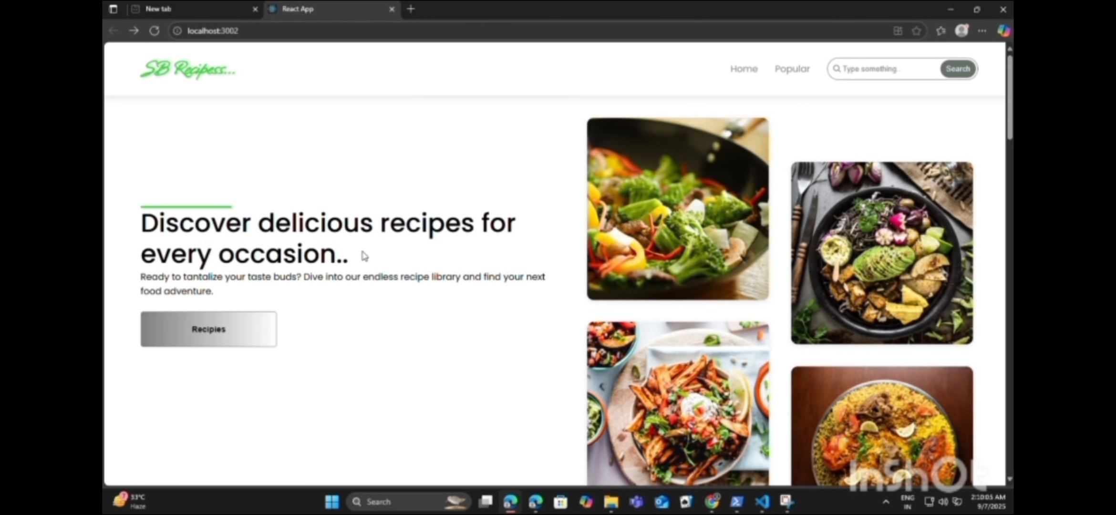

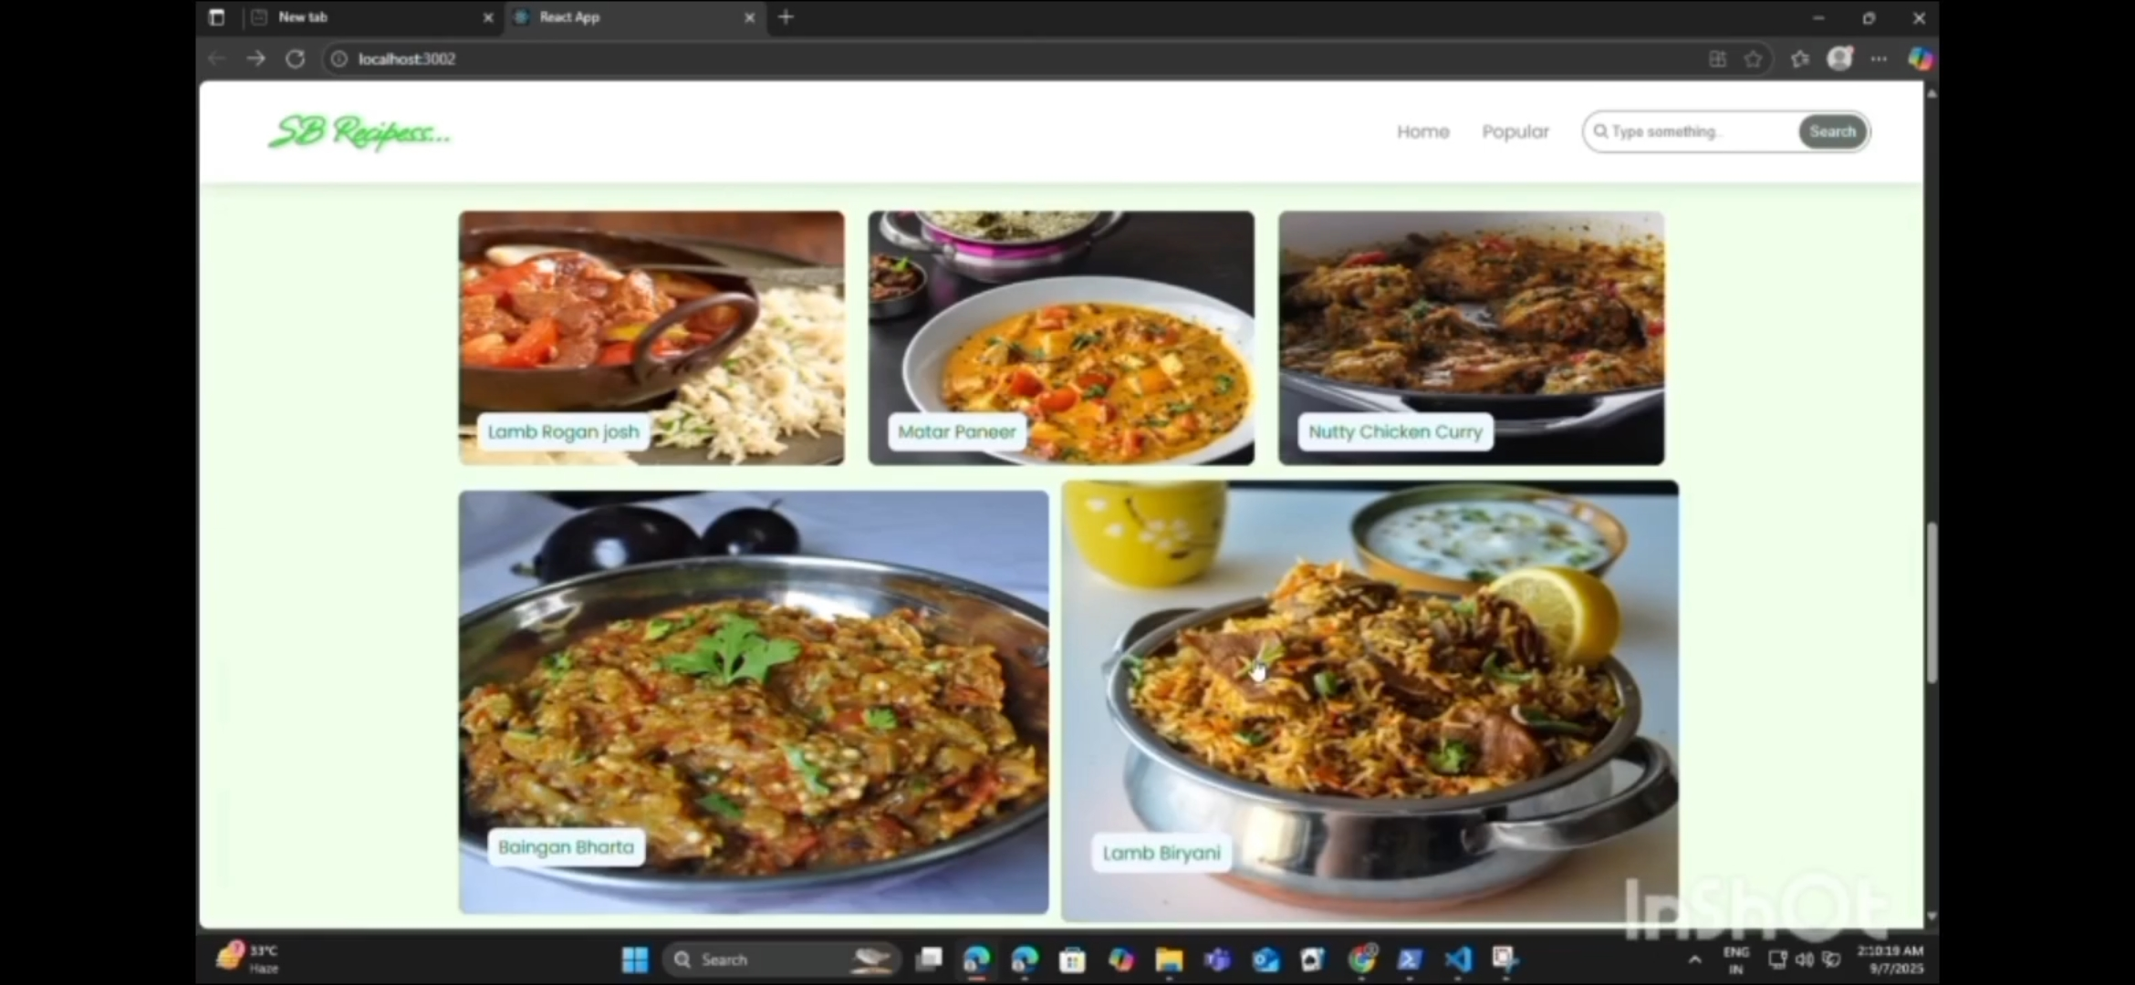

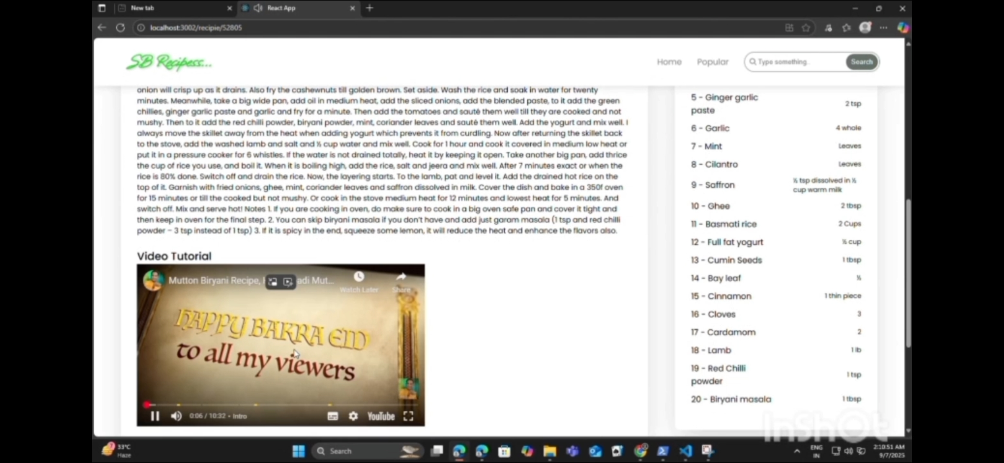

# 11. Testing (Frontend)

- Manual testing with browser dev tools  
- Verified responsive design  
- Tested navigation between pages

# 12. Future Enhancements

- Integrate with a recipe API for dynamic content  
- Add user login and favorites feature  
- Improve UI animations and transitions  
- Add search functionality for recipes